**BC2402**

**Week 1 Class Exercises – Basic SQL**

ER diagram for employee database

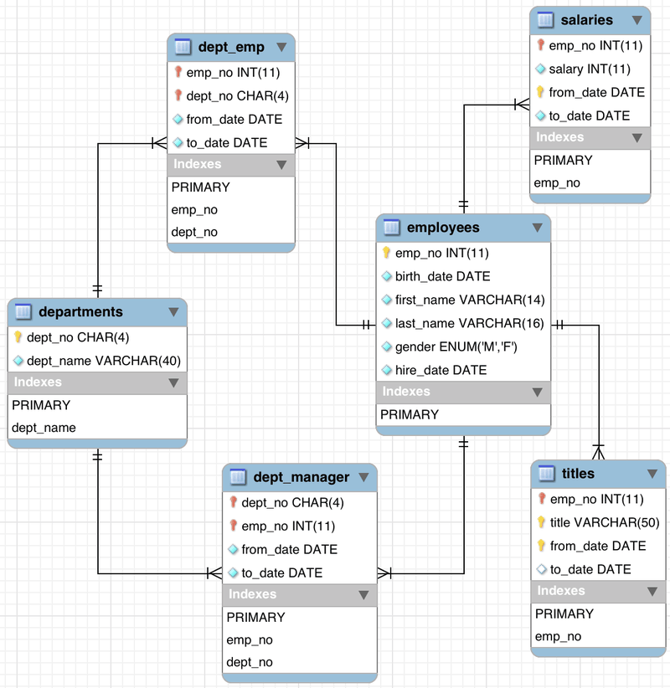

Required: Using the information provided above, specify the SQL syntax for the following:

1. Show a list of all the tables in the database.

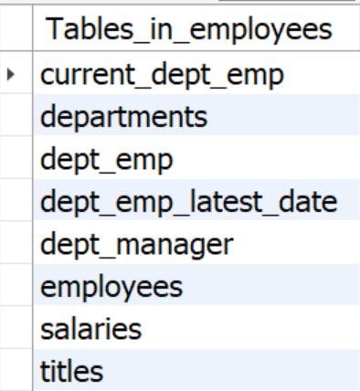

[see something unexpected?]

1. Display the names (first name, last name) and gender of all employees.

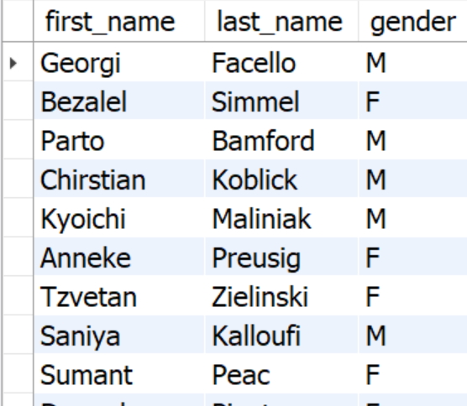

[300024 rows returned]

1. Find all distinct job titles.

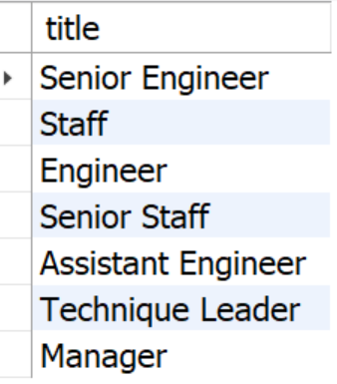

1. What is the total number of employees?

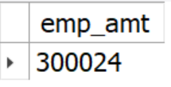

1. How many salary records are there?

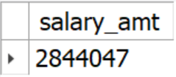

1. How many departments are there?

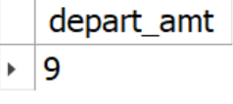

1. What are the names of these departments?

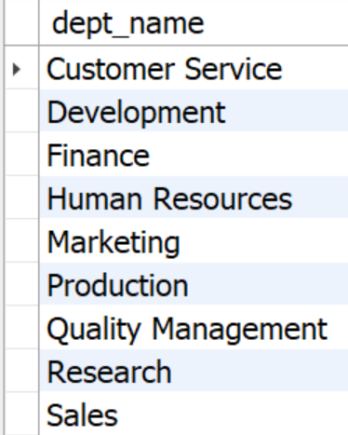

1. Display the names of all female employees.

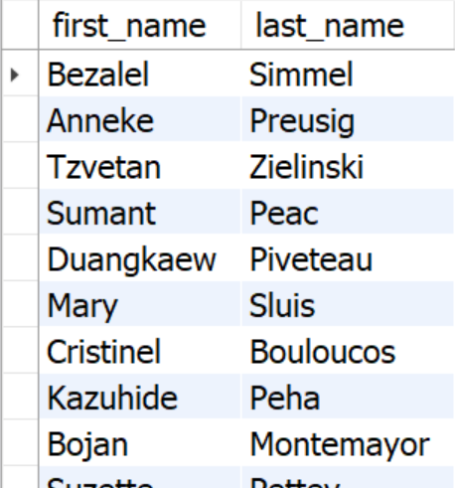

[120051 rows returned]

1. How many male employees are there?

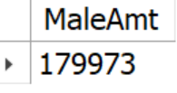

1. Display employee information for those who were hired before the year 1990.

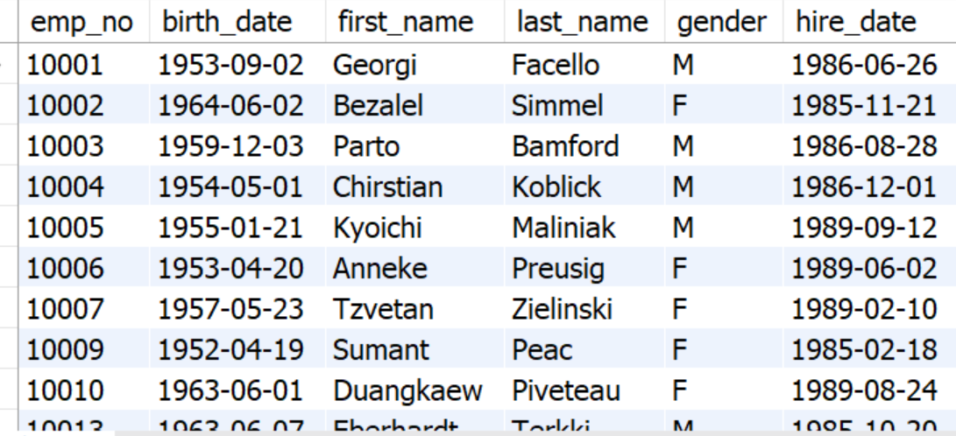

[164797 rows returned]

1. Find male employees who were hired after 1995;

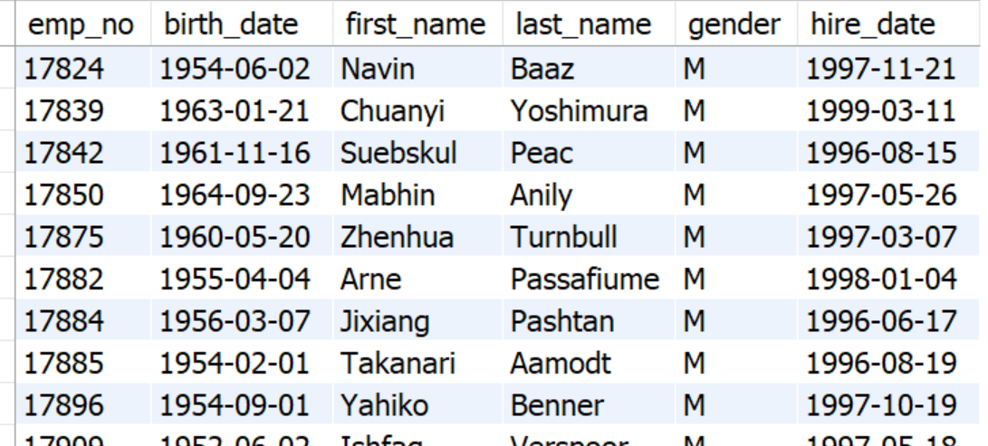

[13234 rows returned]

1. How many employees have their first names as either Adin, Deniz, Youssef and Roded?

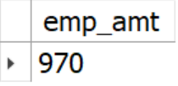

1. How many employees are:
   1. engineers?

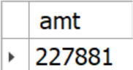 or 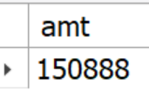

* 1. non-engineers?

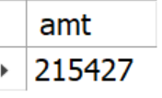 or 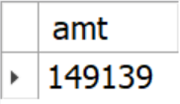

1. How many employees were hired between 1990/01/01 and 1994/01/01.

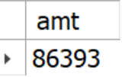

1. Find the list of unique last names of female employees (in alphabetical order), who were born before the year 1970, and hired after 1996.

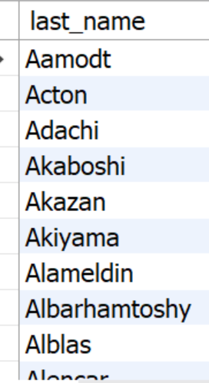 [1567 rows returned]

1. For each gender, how many employees were hired before 1989;

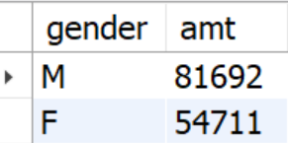

1. For each gender:
   1. how many employees are in each department?

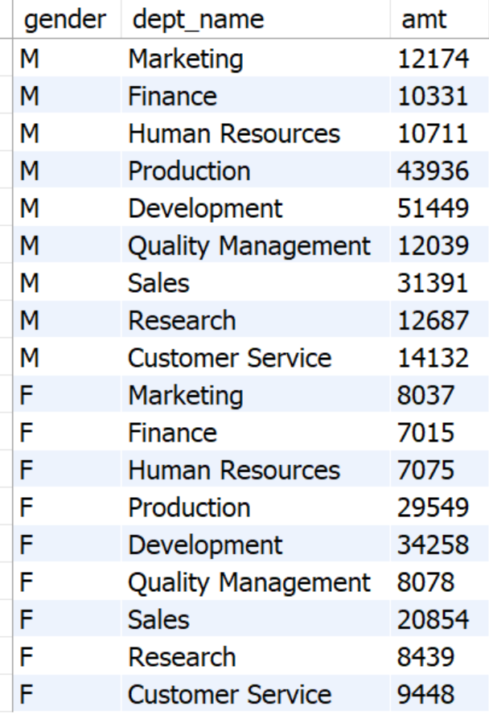

* 1. hired between the years of 1994-1996?

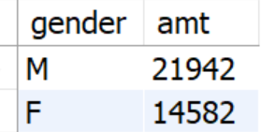

1. List the names of all employees with department managers appointed starting from 1992/09/08 and ending at 1996/01/03.

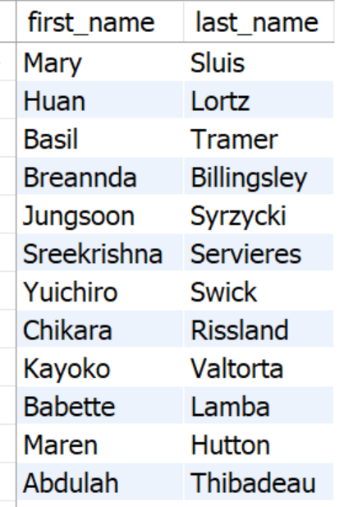[23580 rows returned]

1. List the names of employees and their respective job titles.

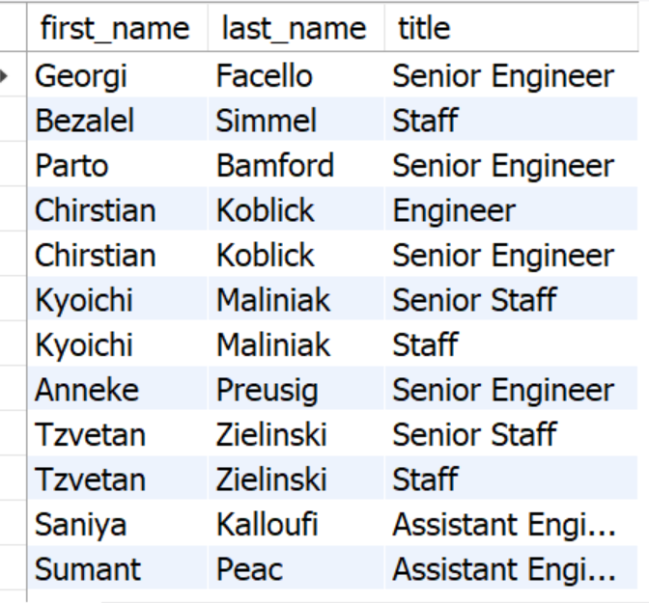 or 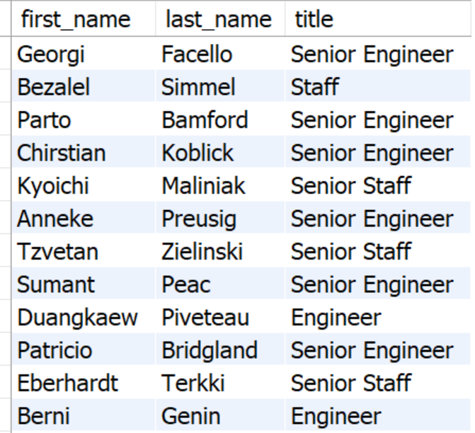

[443308 rows returned] [240124 rows returned]

1. Find the average amount of paid salary (i.e., all salary records) of every department.

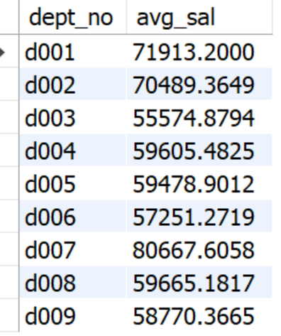

1. Find the average paid salary (i.e., all salary records) of every department and the number of employees.

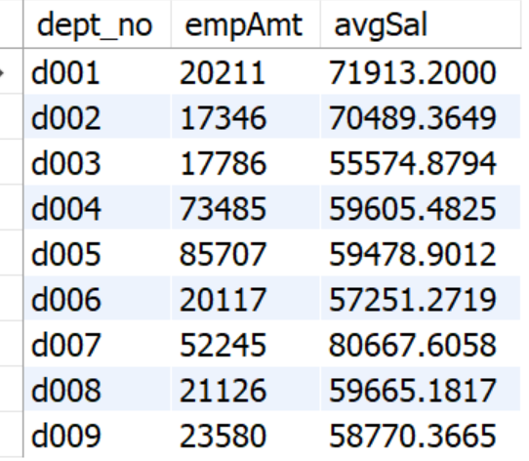

1. Number of employees in every department who have received more than $130000 in a salary transaction.

